Brief Correspondence
Introduction:
All day, every day we are communicating – whether it is talking to people on the telephone or in person, taking dictation and transcribing business correspondence, writing letters, faxes, reports and e-mails. In business, good communication is considered to be a vital part for success. It is essential to learn from our communications, from our successes and our failures, to develop and enhance our communication skills. Communication helps us take actions and make decisions. Communication can be done verbally and non-verbally. The more we write and speak, the more we improve our communication skills. Communication may be defined as: giving, receiving or exchanging information, opinions or ideas by writing, speech or visual means, so that the message communicated is completely understood by the recipient(s).
Communication can either be done face-to-face, or through text messages, e-mails, memos, and letters. All four of these may be used for brief correspondence. However, each one has its own distinguishing characteristics. Here, text messaging and e-mail are the fastest and most efficient means of written communication since they are sent electronically while memos and letters take more time. Between memos and letters, memos are more efficient than letters, primarily because memos have fewer formal parts and because they are usually directed to an audience in the same organization as the sender. Memos also invite a speedy response. In some situations, receivers write a response on the memo they have received and send it back to the writers. In contrast, letters may have many parts and may be sent by postal service or a commercial carrier to readers outside the organization.
Brief correspondence means the exchange of information in a written format for the process of business activities. Brief correspondence can take place between organizations, within organizations or between the customers and the organization. The correspondence refers to the written communication; text messages, e-mails, memos and letters. Hence, oral communication or face to face communication is not a brief correspondence. Or to put in a simple sentence, any communication in the form of the letter is correspondence. A good brief correspondence should be concise in language, accurate and complete, professional in style and appearance, conventional in format, logical in organization and standard in language use.

Importance of Brief Correspondence
A brief correspondence has numbers of importance. Its most important feature is the ease of reaching and communicating with different parties. It is not always possible to meet persons face to face.

1. Maintains a Proper Relationship
It is not always possible for any business or organization to reach to any person in particular. This will cost any business. Here, the brief correspondence will be a rescue for any business. It helps in maintaining the proper relationships between the parties. Brief correspondence strengthens the business. It also helps in the internal communication. It makes communication within the organization more clear and precise.

2. Serves as Evidence
Any written form of communication serves as an evidence. A brief correspondence helps the person in a business to keep a record of all the facts.

3. Create and Maintain Goodwill
Brief correspondence maintains good relationship between business stakeholders. Effective communication through brief correspondence increases an organization's status. Any letter to enquire, complaint, suggestion or feedbacks helps a company grow and maintain goodwill. Business friendships grow in an atmosphere of mutual respect and trust. We can foster goodwill by attending to correspondence as quickly as you can. It also helps in removing the ambiguity and the doubts of the person involved in the business.

4. Inexpensive and Convenient
It is a cheap and convenient form of business communication.

5. Formal Communication
A business communication serves as a formal communication between two persons. It may be a seller and a buyer. It can be between an employee and the employer. The language used is formal and logical.
Memo
The memorandum (plural memoranda), affectionately called a ‘memo’, is a written communication from one person to another (or a group of people) within the same organization. It is normally used for communicating policies, procedures, or related official business within an organization. Memorandum is a document used for internal communication within an organization. It is often written from a one-to-all perspective (like mass communication), broadcasting a message to an audience, rather than a one-on-one, interpersonal communication. Memorandums may be drafted by management and addressed and sent to other employees. Memos are sent to several people in a team when important business matters need to be updated to them or to a single person to have a written record of the information.
Memos serve a variety of purposes: to inform decisions, actions, etc, to request decisions, actions, etc, to remind someone of action required and to provide information of any kind. It may also be used to update a team on activities for a given project, or to inform a specific group within a company of an event, action, or observation. A memo can be as long as a report or as brief as a sentence. The specialty of a memo is: it has informality and immediacy. It doesn't need long addresses and since it is informal, it doesn't require any greeting or farewell. However, memos should be written with proper tone and tactics. Memos are flexible and can be written for different purposes; documentation, confirmation, procedures and recommendation.
Audience for Memos:
Always consider the audience and their needs when preparing a memo. Memos are especially used for communicating within an organization. Since, only the members of the organization receive and respond the memo, the audiences are internal audiences. Memos are often announcements, and the person sending the memo speaks for a part or all of the organization. While it may contain a request for feedback, announcement, policies or procedures, and reference to the existing or new policy. Moreover, a memo reflects the details about implementation time, date, actions, and checklist which can be stored as a written record so that the person receiving the notice does not become confused about the details of what is expected. Even while preparing a memo, we need to consider the backgrounds, opinions, interests, roles, and levels in the organization of the audiences.
Planning Memos:
Generally, memos are not very long in length. But we need to keep in mind that for the sake of writing short memos, we should not skip the information we want to convey. The components like explaining the topic, solution/problem, change in procedures and policies should be clearly mentioned. Besides these, we also mention other specific details like name, date, time, and locations.
Formatting a memo:
A memo consists of the name of the sender (a person or persons or organization's department), name of the receiver (a person or persons or organization's department), date and subject. The heading of a memo looks like the heading of an email. A memo should contain only one idea. If we are writing more than one idea even to the same recipient/s, we are expected to create separate memos.
Parts of a memo:
To: a person/persons/organization
From: a person/persons/organization
Date: 6 October, 2020
Subject: Clear headline is to be mentioned. We can use headline-like expression in the subject part (incomplete in form). However subject should be more specific.
Body:
Introduction: Background information(briefly give the reason for writing, refer to previous communication, who? what? where? when?)
Details: Facts and figures (logical sequence, separate into paragraphs – each one dealing with a separate aspect of the main theme)
Response: An action statement (action you want the reader to take, action you will take, deadline)
Close: A relevant one-liner
Sample 1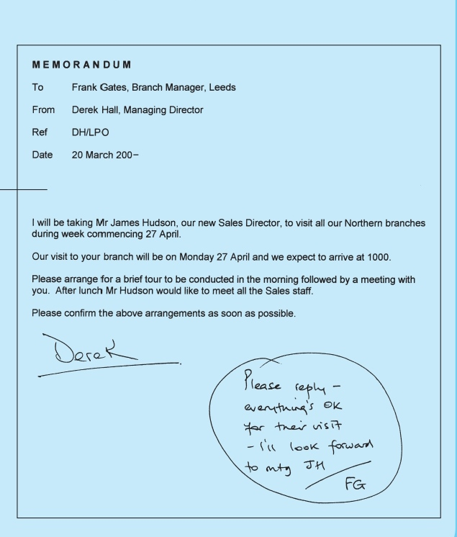

Sample 2
Memo
To: Anderson, Marketing Executive​
From: Jonathon, Market Research Assistant​
Date: 6 Oct. 2020​
Subject: Use of Internet for Marketing ​

Through market research and analysis, it has been discovered that the existing advertising media for the promotion of our products need to be changed. Findings from focus groups and surveys have made it apparent that we need to update our advertising efforts to meet the trends of young adults today.​ ​
Our company needs to focus on the use of the internet as a tool to communicate with our target audience to show our dominance in the clothing industry. By refocusing our advertising efforts of our products, we will be able to maximize the exposure of our product to our target market. ​

I request you to make a thorough study on this.​

(Signature)

Sample 3
Samriddhi College
Bhaktapur

Memo

To: All the faculty members
From: Sandeep Shrestha, Chief
Date: 6 October, 2020
Subject: Training

Nepal Career Building Pvt. Ltd. is organizing a 5-day training on Teaching Methodology from the 9th of October, 2020, 2 pm onwards.
In this regard, I would like to request all the faculty members to fill up the registration form available at the Reception.

Inform prior in case of any inconvenience.

(Signature)

Letter Styles: Letter styles vary. Business letters are usually written on letterhead stationery in block or modified(fully) block letter style. Personal letters include return addresses instead of letterheads and may be written in block or modified block letter style. Block letter style aligns the return address, dateline, and closing at the left margin. Paragraphs are not indented. It is easy to key but may look off-balance. In modified block letter style, the dateline and closing begin at the horizontal center of the page. Paragraphs begin at the left margin.
Two punctuation styles are used in business letters: open and mixed. Open punctuation means that no punctuation marks are used after the salutation and the complimentary close. Open punctuation is considered a time-saving style and is used with block letter style. Mixed punctuation may be used with modified block letter style, in which case the salutation and complimentary close are followed by punctuation marks. The proper punctuation with this style is a comma after the complimentary close and a colon (for business letters) or a comma (for personal letters) after the salutation.
Parts of a Letter
- INSIDE ADDRESS: Complete address of the sender as a return address (personal business letter). A letterhead (company/organization letter) includes the company name, logo, address, and other optional information such and telephone and fax numbers.

- DATELINE: Date the letter was written.

- LETTER ADDRESS: Professional (for example, Dr., Capt.) or courtesy title (Mr., Miss, Ms., or Mrs.), correct name (first name/first initial and last name), title, and address of the person to whom you are writing (no abbreviations). Name here should match the name used in the salutation.
- SALUTATION: Name of the person you want to read your letter. Typically uses professional (for example, Capt., Chief) or courtesy title (Mr., Miss, Ms., or Mrs.) and last name.

- SUBJECT LINE (optional): Focuses on the topic of the letter.

- BODY: Usually two to five paragraphs long but can be several pages and may use headings similar to reports. The letter should look balanced on the page. The body of most letters is single-spaced with a double space (one blank line) between paragraphs. Organization depends on the type of letter you are writing. In block letter style, all lines begin at the left margin. In modified block letter style, all lines generally begin at the left margin except the date and the closing lines, which begin at the center of the page.

- CLOSING: Friendly but businesslike ending. Common closings include Sincerely, Yours truly, and Cordially (never Thank you).

- SIGNATURE LINE: Keyed name and title with space for handwritten signature above.

- REFERENCE INITIALS: Initials (in uppercase) of the person who dictated the letter followed by the initials (in lowercase) of the person who keyed the letter. The two sets of initials may be separated with a slash or a colon. Sometimes only the lowercase initials are used.

- ENCLOSURE NOTATION: Indicates additional documents in the envelope. Often the word Enclosure is followed by a colon and the titles of the enclosed documents are listed.

- COPY NOTATION: Indicates that a copy has been sent to another person or to other people.

